S3 Online Learning
In Stage 3, students have been using Google Classroom as part of their regular lessons this year. Teachers will continue to use this platform to deliver online learning to students unable to attend school in these difficult circumstances.
Each Sunday, teachers will upload new activities to be completed each day. Students will be expected to upload all work into the platform for teachers to mark. Teachers will also be available to answer any questions that students may have. Please note that while we will do our best to be as responsive as possible, there are other tasks that need to be completed that will prevent us from sitting in front of a computer this entire time.
Suggested Timetable
Time | Monday | Tuesday | Wednesday | Thursday | Friday
9.00-10.00 | English  (Writing) | English  (Writing) | English  (Writing) | English  (Writing) | English  (Writing)
10.00-11.00 | English  (Reading) | English  (Vocab/Spelling) | English  (Reading/Spelling) | English  (Vocab/Spelling) | English  (Reading/Spelling)
11.00-11.30 | Break | Break | Break | Break | Break
11.30-12.30 | Mathematics  (Whole Number) | Mathematics  (Number Operations) | Mathematics  (Number Operations) | Mathematics  (Number Operations) | Mathematics  (Other Strands)
12.30-1.30 | History | Science | Geography | Science | Geography
1.30-2.00 | Break | Break | Break | Break | Break
2.00-3.00 | CAPA  (Visual Arts) | PDHPE | CAPA  (Dance and Music) | PDHPE | CAPA  (Drama)

How to Access Google Classroom
1. 2. 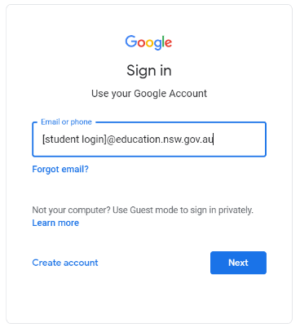 3. 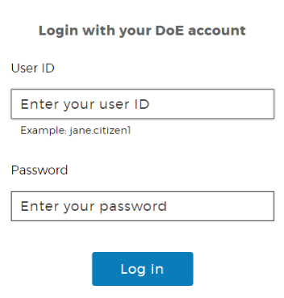 4. 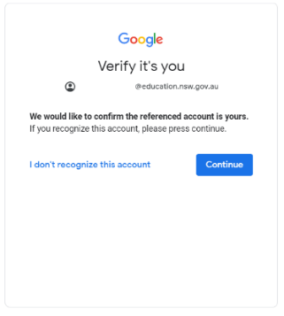 5. 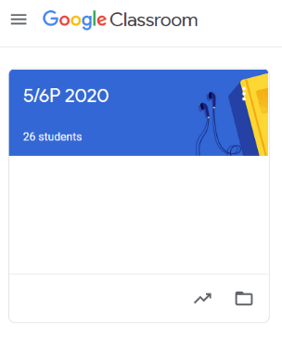
Tasks
Daily tasks will be found in the Classwork tab under the relevant teaching week. Students select the correct date and view assignment which will provide instructions to follow.
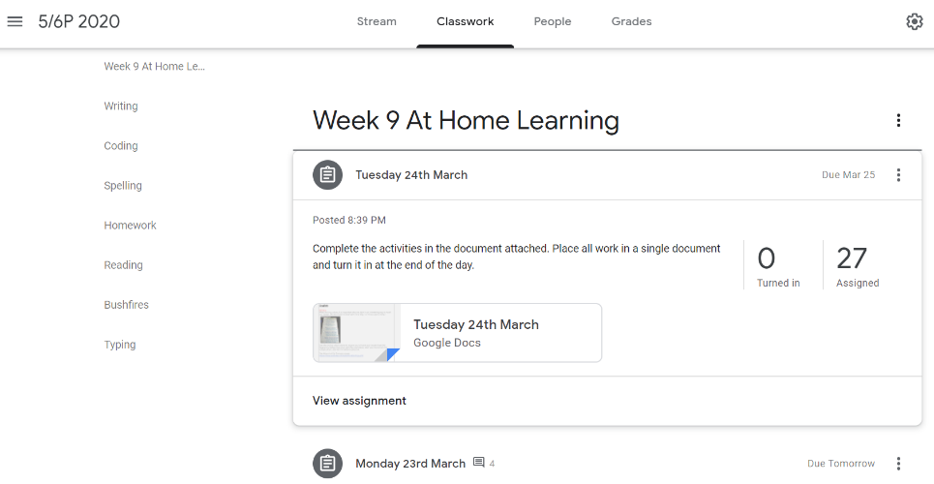
Uploading work
To upload work, students select the add or create option within the assignment. They can either upload a file previously saved on their device or Google Drive OR select one of the Google programs to then produce their work. We are encouraging students to complete all their daily tasks in the one document that will be submitted at the end of the day.
