Stage 3 At Home Learning Tasks
It is important that students maintain a routine and continue learning in these difficult circumstances. Students will have two learning options to select from to ensure this occurs.
Option 1: Online activities OR Option 2: Offline activities

Online Activities  This option is for students with access to the internet and suitable devices (computers, laptops, Chromebooks, tablets) | Offline Activities  This option is for students without access to the internet and suitable devices.
All classes in Stage 3 use the online platform Google Classroom in their regular lessons each day. Each week teachers will be posting new online activities in their Google Classrooms to be completed by students daily. There will be periods of time allocated throughout each day for students to interact with their teacher and their peers. Students will be expected to submit work by uploading documents into the virtual classroom. | Several activities have been developed to ensure all students can continue their learning. We advise students use an exercise book to record all work completed.

How to Access Google Classroom
1. 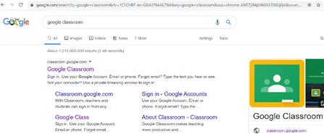 2. 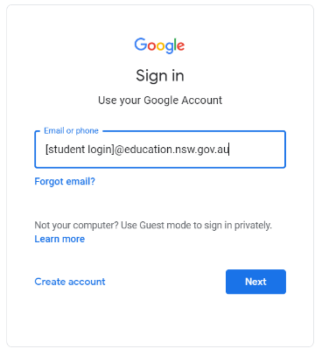 3. 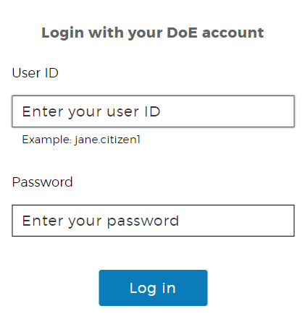 4. 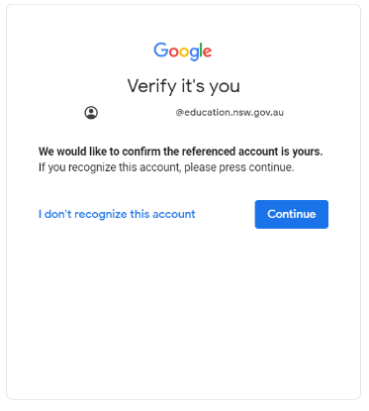 5. 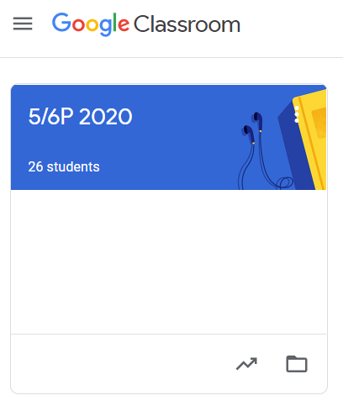

Offline Activities
Suggested Timetable
Time | Monday | Tuesday | Wednesday | Thursday | Friday
9.00-10.00 | English  (Writing) | English  (Writing) | English  (Writing) | English  (Writing) | English  (Writing)
10.00-11.00 | English  (Reading) | English  (Vocab/Spelling) | English  (Reading/Spelling) | English  (Vocab/Spelling) | English  (Reading/Spelling)
11.00-11.30 | Break | Break | Break | Break | Break
11.30-12.30 | Mathematics  (Whole Number) | Mathematics  (Number Operations) | Mathematics  (Number Operations) | Mathematics  (Number Operations) | Mathematics  (Other Strands)
12.30-1.30 | History | Science | Geography | Science | Geography
1.30-2.00 | Break | Break | Break | Break | Break
2.00-3.00 | CAPA  (Visual Arts) | PDHPE | CAPA  (Dance and Music) | PDHPE | CAPA  (Drama)

It is expected students will use texts sourced from our school library, from the For the Love of Reading Program, TV programs and personal texts |  | English Activities
A narrative book | Reading  - Read your favourite book or magazine and write a review.  - You are the new illustrator and you must redesign a new book cover.  - Read a page or two of your favourite book to a friend or a relative.  - Remember to follow the rules of punctuation, pause for effect and make eye contact with your audience.  - Write some questions for the author. | Writing  - Make a connection with the text and discuss a choice the character made. List the 3 positives and 3 negatives about the decision.  - Write about your favourite character in a book or movie. Outline specific features that make them your favourite character.  - Create a character of your own and write a story about it. Remember to include the illustrations.  - Write a sequel to the story as a comic.  - Write a diary entry from the perspective from a character in the story. | Vocabulary  - It’s important to add words to our vocabulary so write out 5 or more new words from your text.  - Write the words in a big size on paper and put them up on the wall or fridge if you can  - Define these new words by asking someone or using a dictionary if possible.  - Practise your spelling words each day and complete an activity from the spelling matrix.
An informative text | Reading  - Predict before you read a book or magazine that can teach you something appropriate.  - Activate prior knowledge while watching a documentary.  - Sketch something you’ve learnt.  - Tell a someone 3 great facts about what you’ve learnt.  - Watch a documentary with your family and then run a quiz. | Writing  - Discuss how the topic explored helps our world. Write at least 3 reasons with evidence.  - Write about an idea you would invent and explain it’s 3 best features with a labelled diagram.  - Write a summary of a news item you either have seen or read.  - Write a letter to a family member telling them about what  you did yesterday. Add some fictional details and have them guess which details are fact or fiction. | Vocabulary  - Use the glossary in an information text and write the meaning of 3 words you didn’t know  - Create a glossary to match an informative text read.  - Create a mind map using language from a text read or watched.  - Use the words about the topic to create an artwork.  - Create a cross word using vocabulary from a text read.  - Practise your spelling words each day and complete an activity from the spelling matrix
A persuasive text | Reading  - Watch a commercial on TV and write down the product  - Can’t find an ad? Check your mailbox for ads or ask your parents or carer for old magazines.  - Write down one good feature of the product or describe an image/part of the ad you liked  - Outline why or why the product would help you.  - Analyse an ad using knowledge of visual literacy. | Writing  - In advertising we show the five pillars of marketing which include product, place, price, promotion, and people. Can you see any of these parts in the ad?  - Write about your favourite ad and describe 3 reasons why you like it.  - Create an ad of your own for a product. You must justify why you chose the product. Next create your ad with slogans and illustrations or more.  - Create an advertisement to convince people that children should learn at home rather than school. | Vocabulary  - Write the meaning of the following visual literacy terms: salience, reading path, real vs ideal, layout, camera angle  - Find and record the words which show modality in an advertisement.  - Find examples of exaggeration.  - Write unknown words in a big size on paper and put them up on the wall or fridge if you can.  - Practise your spelling words each day and complete an activity from the spelling matrix

Mathematics Activities
Whole Number | Counting  - Make a 6-digit number using playing cards and count forwards and backwards by tens/hundreds/thousands  - Play ‘Buzz off’  - Create a board game. Draw a grid with start and finish. Write numbers on each square that you can count. Make a rule that when you land on the square you must count in 1s from that number 5 times to stay on that square. Vary the rule for each game i.e. count in 10s 5 times etc | Place Value  - Use playing cards/dice and make a 5-digit number:  - make the largest/smallest possible number  - make an even/odd number.  - identify and write the number before and after the number created  - state the place value of each numeral  - make another 3 numbers and place them in ascending or descending order | Patterns  - Create and record different patterns.  - Create an artwork using repeating patterns.  - Draw a 100s chart and colour known patterns.  - Design a tiling pattern for a bathroom.
Number Operations | Addition and Subtraction  - Play ‘How close to 100’ with a partner by rolling a dice and adding to your previous number each time. Challenge yourself by using multiple dice. Reverse backwards to zero once you get to your chosen number by subtracting each roll.  - Use catalogues and create a shopping list given a budget of $100  - Watch the news and calculate the increase of Covid-19 cases in NSW each day | Multiplication and Division  - Play ‘Buzz Off’ or ‘Times table shootout’  - Use dice to create multiplication questions to solve e.g. 56 x 4  - Write a 2-digit number and record its factors. Is it a prime or composite number?  - Look at a cupcake/muffin tray. How many can you make using 1 tray? How many can you make using 6 trays?  - Look at a simple recipe. What would be the recipe if you had to make double the amount? | Fractions and Decimals  - Create an artwork or picture to represent a variety of fractions.  - Help a family make a recipe and interpret the fractions for them.  - Cut 6 strips of paper of equal length. Model different fractions and compare their sizes.  - Use a calculator and record fractions as decimals.  - Record decimals on a number line.
Other strands | Geometry  - Construct prisms and pyramids using a variety of materials, for example plasticine, paper or cardboard nets, connecting cubes. Choose two objects you made. Sketch the front, side and top view. Make and then draw as many different nets as possible for the objects you selected.  - Create a 3D model robot using recycled materials or household items e.g. lego, play dough. Paint or decorate it when once constructed. Post a photo to your Google Classroom.  - Get 24 match sticks and try and make different triangles using ALL the match sticks (e.g. scalene, right-angle, equilateral triangles) | Measurement  - Find a timetable for local public transport. Choose a route, start points and endpoints. Calculate how long the trip will take. Plan a day trip involving at least two stops. Create your own timetable for the day. Calculate the time to travel from each stop to the next. Convert timetable times from 24-hour to 12-hour time.  - Fly paper planes and record their distances.  - Use a map and calculate the distances between locations  - Draw a map of a fictitious city. Don’t forget to include a grid, a scale, a legend, a title and locations | Statistics and Probability  - Analyse a Covid-19 graph. Write some statements explaining what it shows.  - Collect data about how you spend your time throughout the day. Categories could include eat, playing video games, homework, sport etc. Collect data over a week and graph your results.  - Run a chance experiment by making your own spinner out of paper, a pencil and a paperclip. Record the possible outcomes, write a prediction based on the likelihood of an event occurring and record the results.

Other Key Learning Area Activities
History | Harmony Day  - What do you think the theme of Harmony Day means “Everyone belongs”. How can we make everyone feel like they belong?  - Create a recipe book of your favourite dishes from your culture or a variety of cultures (include family recipes). Ask a parent/carer to cook it with you.  - Interview a family member or friend to understand their reasons and experiences coming to Australia (the interview could be recorded) Create a list of questions to ask such as: Why did they come? Why did they choose Australia? How is it different to the country they were born in?  - Imagine you moved to another country. Where might you move? Write about your feelings. | Personal History  - Research your family history by interviewing your parents and grandparents.  Questions may include:  Who were your parents? Name your siblings? When were you born? Where did you grow up? What was life like when you were younger? What jobs did you do? What did you do for leisure?  - Write a biography using the information discovered.  - Create a family tree.  - Compare and contrast your life with that of your parent/grandparent.
Science | Forces  - Use forces (pushes/pulls) to make objects move. Identify different types of forces that act on objects. For example, gravitational, magnetic, buoyancy, applied forces (push, kick). Observe the effect of changing the variables on movement such as, surface it moves on (rough or smooth), strength of force used. Record predictions, observations/ measurements (photos, drawings, tables).  - What factors affect the movement of objects? Observe the impact of friction on different surfaces, air resistance and/or buoyancy on the movement of objects. Plan and perform a scientific investigation. Choose one of these forces to investigate. Identify a testable question, variables, steps, method to record observations/measurements.  - Find a small ball. How does that move? Plan a machine that moves the ball from one side of the room to the other without you touching it. Find things around your house like a chair to start your machine from, for example, a tube from a lunch wrap to make a tunnel, some boxes to make a track. Record your times and review your design for success | States of Matter  - Write a description and draw a picture for each term- solid, liquid and gas.  - Classify the following materials as solids, liquids or gases:  stones  icing sugar  play doh  elastic bands  cooking oil  honey  air  Why do you think that powder is a solid and not a liquid? What test could you take to decide that honey is a liquid?  - Investigate changing the states of matter of objects. How would you turn liquid water into a solid? How would you turn the solid chocolate bar into liquid?
Geography | Bushfires  - Create a poster that teaches your family about bushfires.  Answer the questions in your poster:  - What are the conditions under which bushfires occur?  - What are the factors affecting the spread of bushfires?  - What are the main causes of bushfires?  - How do bushfires spread?  - How to prepare for a bushfire? | Virtual Reality Geography Lessons  - Create a physical model of the Virtual Reality world you created as part of VR lessons. Think about the land, the natural elements added and the scenes informing the user how to prepare for bushfires.

Other Key Learning Area Activities
CAPA | Visual arts  - Find an interesting object around the house and sketch it  - Create a collage using old magazines.  - Create a sculpture using items found around the house.  - 3D hand art  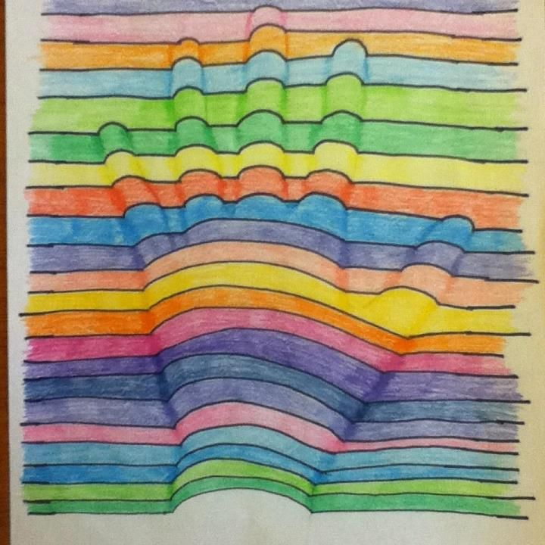 | Music and Dance  - Find different items around the house to make musical instruments. Experiment with beat, pitch, duration, tempo to create your own composition.  - Create your own ‘cup song’  - Change the lyrics to a known nursery rhyme and perform it.  - Create a dance routine to your favourite song.  - Go outside. Experiment with how to move to different spaces within this outdoor area using different movements. | Drama  - Write a script and have different family members perform a role. Think about costumes and props.  - Re-create a scene from a favourite book/movie  - Practise your improvisation skills by playing charades  - Re-write a scene from a book or movie as reader’s theatre and perform it for an audience  - Watch the news and perform a ‘news broadcast’ for your parents. You may want to include an update on the Covid-19
PDHPE | Health  - Keep a food diary. Calculate how many serves of fruit and vegetables you eat each day. Does it meet the recommended servings of 5 vegetables and 2 pieces of fruit?  - Use the nutritional information recorded on food packaging to work out how much sugar you eat in one day.  - Prepare a healthy snack each day and describe what makes its healthy. | Physical Exercise  - Keep a physical activity diary. Calculate how much time each day was spent on physical activity. Identify two personal goals for a more active lifestyle. Brainstorm how you could achieve each goal.  - How could you improve your throwing, catching or kicking skills? Write a list of strategies you could use to improve your skills. Practise how to kick, throw, or bounce a ball towards a target. Observe how you can change your body position to apply different amounts of force to the ball.  - Recreate Olympic Games events e.g. shotput using socks in a ball, javelin with straws, volleyball with balloons etc. Give each family member a country and have them wear a uniform. Make Gold, Silver and Bronze Medals. | Personal Development  - Develop your interpersonal skills by helping others:  - Include your siblings in games  - Play video games less and interact with others by playing board games or making up games  - Do chores around the home  - Avoid wasting food  - Washing hands for 20 secs  - Use coughing/sneezing etiquette

