

**Some Suggestions:**

Cathy Freeman (athlete), Ernie Dingo (actor, presenter), Deborah Mailman (actress), Samantha Harris (model), Jessica Mauboy (singer), Leah Purcell (actress, writer), Noel Pearson (lawyer, activist), Adam Goodes (AFL football player), Linda Burney (politician), Mandawuy Yunupingu (singer/musician/songwriter), Edie Mabo, Joyce Clague (political activist), Evelyn Scott (social activist), Albert Namatjira (artist), Evonne Goolagong Cawley (Tennis player).

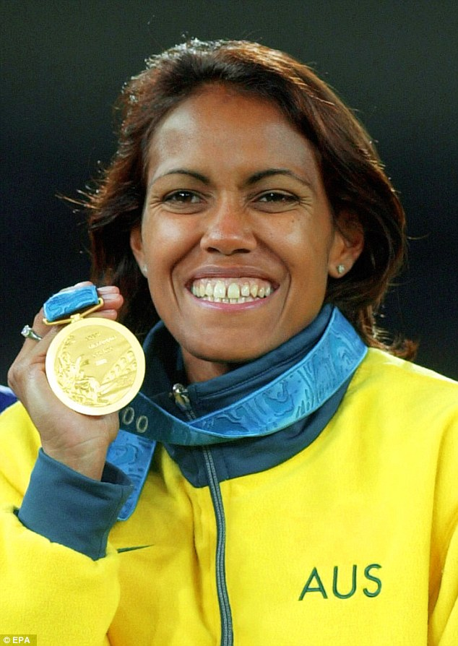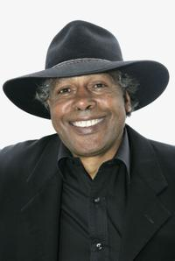

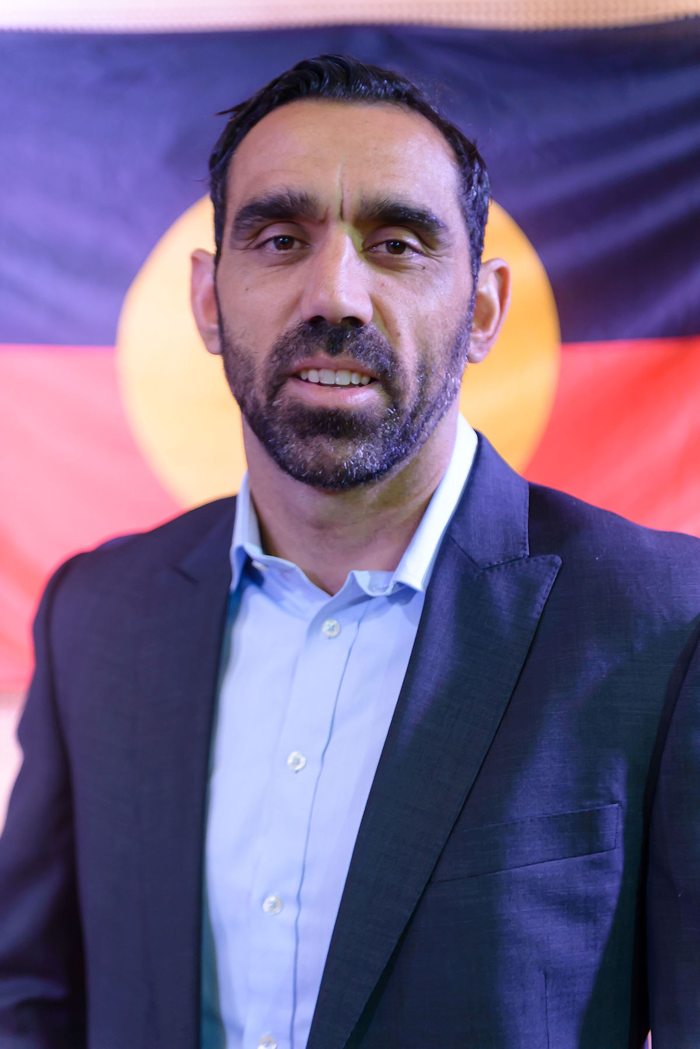

**Project Task**

This Term, Stage 2 students will be learning about Community and Remembrance focusing on our Aborignal community. To compliment the unit of work, students are encouraged to **research a famous or local indigenous person of their choice.**

In Week 3, students should take the opportunity to develop a plan of attack to complete their project over the term.

When researching their Famous Indigenous Person students may choose to consider the following…

* Who is the famous indigenous person he/she will be researching? (Week 3)
* The mob they belong to (Week 4)
* Their birth date/age (Week 4)
* Where they live (Week 5)
* Languages spoken (Week 5)
* Where they grew up (Week 6)
* Their background/ childhood (Week 6)
* Why are they famous or successful? Achievements? (Week 7)
* What are they doing now? (Week 8)
* Interesting facts (Week 9)

It is suggested that students use Week 10 to review, edit and practise presenting their research.

**Presentation of your project:**

Students may choose to present a speech or use Google Slides, Microsoft PowerPoint, Microsoft Word, create a poster or be creative in the recording of their research. Presentations (or speeches) should be **no more than 3 minutes** in length.

**Homework: Famous Indigenous Person**

**Stage 2 Term 1**

**Due Date:**

**Term 1 Week 10**